On this map make a key for each of the 6 policies/events listed below. Then, color each country affected by each policy. Use your book to find the countries and their locations. On the back of the map you need two bullet points per policy: (1) What the U.S. action was (2) Why?/Goal.
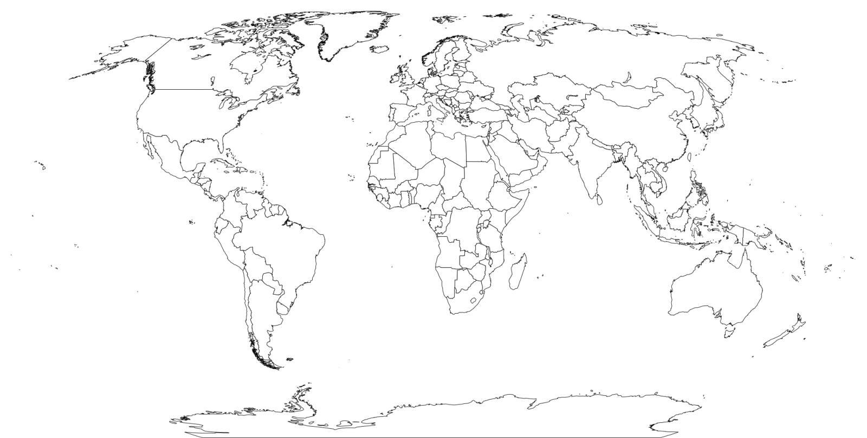
Terms: Open Door Policy, Panama Canal, Spanish-American War, Roosevelt Corollary, Dollar Diplomacy, Mexican Revolution

