Progressive Age Instagram Photo Album Name:
DUE DATE: Monday October 29th start of class
- You will be creating a photo album highlighting the important reforms and figures of the Progressive Era.
- Printer paper will be provided for you to complete this assignment. You are not going online and actually creating Instagram accounts/albums. You are welcome to make a page template on word and to print pictures, but all writing needs to be done by hand.
- Materials Provided: Paper, glue, markers, colored pencils, rulers, magazines. You are welcome to bring your own supplies as you see fit to fulfill your vision.
- You will turn this paper rubric in with your project.
What does each page need?
Cover Page
- The cover page may be decorated however you like. This may contribute creativity points.
Reform Pages
  - Account name
  - A picture (drawn or printed out) that directly relates to the reform in some way
  - A handwritten caption (paragraph) detailing the problems the reform was addressing and explanations of significant policies (detailed below) implemented to address these problems. These need to be in complete sentences and are written in the 1st person. Think of this as writing from the perspective of a group that helped create the reform.
    - Example: We began the prohibition movement to…
President Pages
  - Account name
  - A picture (drawn or printed out) that directly relates to the particular president in some way
  - A handwritten caption (paragraph) detailing the years each served as president and the successes/failures of that president as it pertains to progressive policy. These need to be in complete sentences and are written in the 1st person. Think of this as the president’s reflecting on their progressive legacies.
    - Example: While serving as #POTUS from 1909-1913 I oversaw the…
Reform Pages and Content: Be sure to explain these topics in your reform descriptions, do not just name drop them. You can layout/format the pages however you like as long as all information is included.
- Democratic Reforms: Direct Primary, Initiative, Referendum, Recall, “Laboratory of Democracy”, Seventeenth Amendment
- Women’s Suffrage: NAWSA, Carrie Chapman Catt, Alice Paul, tactics used, Nineteenth Amendment
- Child Labor, Health, and Safety: Keating-Owen Act, Triangle Shirtwaist Company Fire, Zoning Laws
- Prohibition: Frances Willard, WCTU, Eighteenth Amendment
- Big Business: Northern Securities v. U.S. , Department of Commerce and Labor, Hepburn Act, Meat Inspection Act, Pure Food and Drug Act, Clayton Antitrust Act
- Conservation: Newlands Reclamation Act, Gilbert Pinchot, United States Forest Service
- Income Tax and Federal Reserve: Sixteenth Amendment, Underwood-Simmons Act, Federal Reserve Act, Federal Trade Commission
- Progressive Limits: W.E.B. Du Bois, Niagara Movement, NAACP, ADL
President Pages
- Theodore Roosevelt
- William Howard Taft
- Woodrow Wilson
Rubric
- You will receive a daily grade for this project all seven class days that we work on it.
  - Not being on task/being on phone will result in a loss of points
  - If you finish and turn it in before the due date find something to do. You should never be sitting on your phone.
- Points will be deducted for not following directions
- Use your book to find this information not the internet.
- You are encouraged to add creativity and personality to your project. As long as you have the information I have requested the way you format or add to each page is entirely up to you. This creativity element is detailed below and does factor into your grade on this project.
  - Creativity Examples: Advertisements, comments, likes, hashtags etc. Be creative!!!!!!
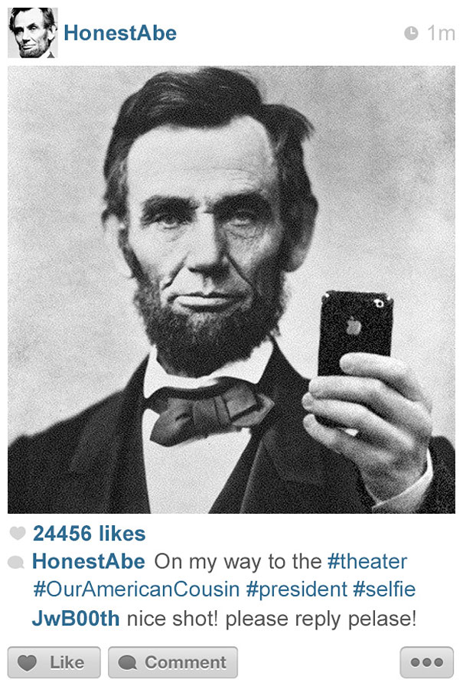
SCORING RUBRIC
6 Pages Total (Front and back)
Creativity, Effort, Neatness /10
Each page (4 points) /44
Project Total /54
Use of Class Time /21

Comments:

